**Exploratory Study of Potential Negative Safety Outcomes Associated with UAV-assisted Construction Management**

Yiye XU1; Yelda TURKAN2; Ali A. KARAKHAN3; Ding LIU4

1 Ph.D. Student, S.M.ASCE, School of Civil and Construction Engineering, Oregon State Univ., 101 Kearney Hall, Corvallis, Oregon 97331; [xuyiy@oregonstate.edu](mailto:xuyiy@oregonstate.edu)

2 Assistant Professor, A.M.ASCE, School of Civil and Construction Engineering, Oregon State Univ., 101 Kearney Hall, Corvallis, Oregon 97331; [yelda.turkan@oregonstate.edu](mailto:yelda.turkan@oregonstate.edu)

3 Ph.D. Candidate S.M.ASCE, School of Civil and Construction Engineering, Oregon State Univ., 101 Kearney Hall, Corvallis, Oregon 97331; [karakhaa@oregonstate.edu](mailto:karakhaa@oregonstate.edu)

4 Ph.D. A.M.ASCE, School of Civil and Construction Engineering, Oregon State Univ., 101 Kearney Hall, Corvallis, Oregon 97331; [liudi@oregonstate.edu](mailto:liudi@oregonstate.edu)

**ABSTRACT**

A variety of technologies have been implemented in the construction industry at an increasing rate. With the on-going development of assistive remote sensing and information technologies, as well as computer vision techniques, Unmanned Aerial Vehicles (UAVs) have a great potential to influence construction performance positively in terms of safety, quality, cost, and schedule. However, the implementation of UAV-based technology can bring new safety risks to construction stakeholders. Previous research studies on the topic have touched on the potential negative impacts of using UAVs on construction projects, but the safety concerns have not been adequately studied. This exploratory study aims to identify and summarize the construction safety risks associated with the use of UAV-assisted management methods in construction projects. The authors identified and categorized the safety concerns using an extended review of scholarly and industry publications on the topic of UAVs in construction. To propose effective solutions to mitigate the potential safety risks associated with the use of UAVs in construction, the Hierarchy of Control (HoC) for safety management is utilized to evaluate the effectiveness of each solution. As a result of the use of the HoC, each proposed/identified potential solution is evaluated in terms of effectiveness to eliminate a certain type of hazard. The present study makes an important contribution to practice by identifying safety risks associated with the use of UAVs in construction and highlighting solutions to mitigate potential safety risks associated with the use of UAVs. It is expected that industry professionals and practitioners could use the presented knowledge to identify the safety risks construction workers are exposed to and implement proper controls to mitigate the hazards and prevent incidents from occurring.

**INTRODUCTION**

The construction industry, as a result of its stubbornly high fatality and injury rates, is considered one of the most hazardous industries in the United States (U.S.). In 2017, 971 worker fatalities were recorded in the U.S. construction industry (OSHA 2019). The construction workforce accounts for only 4.3% of the entire U.S. workforce, but is responsible for 20% of the total worker fatalities among all industries (BLS 2017). To improve workplace conditions and curb the high number of injuries, both practitioners in the industry and researchers in academia have implemented advanced technologies at an increasing rate (Guo et al. 2017). For example, the uses of commercial Unmanned Aerial Vehicles (UAVs), also known as drones, in the construction industry has increased rapidly in the last decade. It was reported that the use of UAVs in the construction industry has skyrocketed year after year with a rate of 239% (DroneDeploy 2018). UAVs can be used for multiple purposes and tasks including pre-construction mapping and surveying, construction progress tracking and quality control, and safety inspection control (Irizarry and Costa 2016, Siebert and Teizer 2014, Xu and Turkan 2019).

Although the benefits of using UAVs are proven for a variety of applications in the construction industry, in 2019, the Federal Aviation Administration (FAA) has so far received more than 100 sighting reports of unsatisfactory UAV operations each month from pilots, citizens and law enforcement (FAA 2019). Such statistics bring doubts as to whether it is safe enough to adopt commercial UAVs for construction management. The goal of this study is to identify and summarize the safety risks associated with the use of UAVs in construction, and to propose and validate solutions to mitigate the identified risks.

**BACKGROUND**

**Hierarchy of Controls**

To manage workplace safety and mitigate potential hazards, the Hierarchy of Controls (HoC) is a typical approach. In simple words, the HoC is a system designated to minimize or eliminate safety hazards through five levels of control. In the order of decreasing effectiveness, the five levels are Elimination, Substitution, Engineering, Administrative, and Personal Protective Equipment (PPE). The system has been widely accepted by numerous safety organizations, researchers, and major industries (NIOSH 2015).

Elimination and substitution levels of safety control are recognized to have the highest effectiveness levels according to the HoC. Typically, those levels of control occur in early design and planning phases. For example, on-site construction risks could be addressed during the schematic and detailed design development phases to eliminate or significantly reduce safety hazards associated with the construction of the design in later stages. In contrast, engineering and administrative controls are usually implemented during construction operations. Because they are implemented after the design is fully developed, engineering and administrative controls do not eliminate the hazards associated with the execution of the design; instead, they are used to either isolate workers from the hazards or improve worker awareness of the hazards, respectively. Finally, the bottom level of safety control is to use PPE. Although PPEs are indispensable elements of any safety plan, they are considered the least effective method according to the HoC.

Previous studies primarily focused on how UAVs can be used in safety management to mitigate safety risks in construction (Melo et al. 2017, Canis 2015), but they overlooked the potential safety hazards created by this technology. The present study aims to investigate this important area by identifying and summarizing safety risks associated with the use of UAVs in construction. Following the identification and summarization of safety risks associated with the use of UAVs, solution methods to mitigate the identified safety risks are examined. To achieve the research goals, the present study relies on a review of available literature on the use of UAVs in construction. Both scholarly and industry publications are examined. Scholarly papers include journal articles and conference proceedings papers; while, industry publications consist of news articles, blogs, and reports published by professional organizations and associations in the Architecture, Engineering, and Construction (AEC) industry. Given this is an exploratory study, unstructured review of literature involving cross referencing, a.k.a., snowballing sampling, is utilized as recommended by Gent et al. (2011). Despite the limitations of unstructured literature review, it is considered acceptable for a preliminary investigation (Karakhan et al. 2019).

**HAZARDS ASSOCIATED WITH UAV-ASSISTED CONSTRUCTION MANAGEMENT**

Safety risks associated with the use of UAVs that construction workers might be exposed to are summarized and categorized in Figure 1. Two types of safety risks are recognized: unsafe work environment and unsafe worker behavior. This categorization was inspired by Heinrich’s Two-Factor Model, which states that unsafe conditions and unsafe behaviors are two primary factors leading to workplace accidents (Heinrich 1959). Each type is described below in more detail.

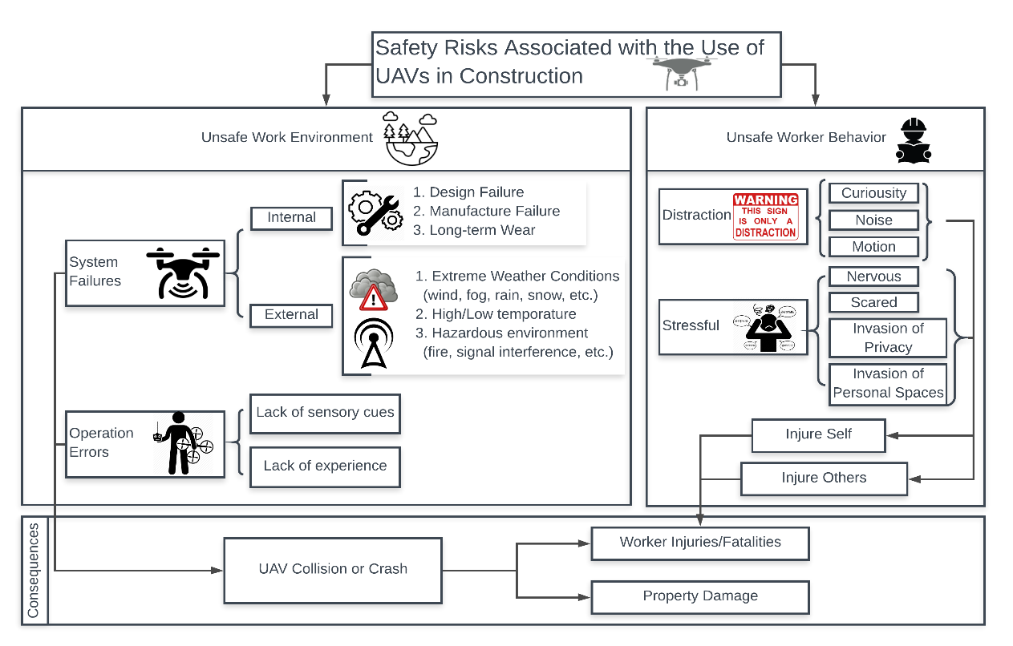Figure 1. Potential safety risks and outcomes associated with the use of UAVs in construction

**Unsafe Work Environment**

The small size of UAVs is inherently dangerous due to the fact that they have mass, velocity, and operate above construction workers, typically at the same height as the structure, but less than 400 ft (FAA 2019) depending on the purpose of the operation. These characteristics can be highly hazardous to the people underneath the operating UAVs in case of a mechanical failure or operational error (Clarke 2016). Construction workers can be hit by an out-of-control or falling UAV and, as a result, get injured or even die. In addition, out-of-control and falling UAVs can hit other objects (e.g. onsite temporary or permanent structures) and cause property damage (Howard et al. 2017). Such damage could also cause worker injuries and fatalities due to flying debris or structures collapses. Moreover, there is a possibility that the out-of-control or falling UAVs could cause fire if hitting flammable construction materials (e.g., oil or gas), resulting in catastrophic property damage and human injuries and fatalities to the project as well as surrounding structures (Opfer and Shields 2014). There are two main reasons leading to out-of-control or falling UAVs: mechanical system failures and operational errors, both of which are discussed in more detail below.

*Mechanical System Failures*

Mechanical system failures of UAVs can be caused by both internal and external factors. Internal factors are those unintended failures related to the design and/or manufacture of the product (e.g., defective motors or propellers) that are not caused by operational errors. Many commercial UAVs available in the market are not of high quality and sometimes do not meet the safety standards (Plioutsias et al. 2017). On the other hand, external factors are factors related to external climate and physical conditions. To produce a technology that is lightweight and durable which are preferred characteristics of any UAV, materials such as aluminum and composites are used. However, producing lightweight UAVs makes the technology vulnerable to high winds and other extreme weather conditions, reducing its stability during operation and exposing it to potential failures and system errors (Opfer and Shields 2014).

Moreover, rain and extreme temperatures could threaten the sensitive components of the technology (e.g. battery), causing functionality errors and system failures. Examining UAVs available in the market for commercial use, manufacturers typically recommend operation in certain conditions where temperature ranges from -10°C to 40°C (14°F-104°F) (DJI 2019). However, many construction projects operate even when temperature falls beyond the aforementioned threshold. Operating UAVs under extreme weather conditions exposes them to high likelihood of failure. Signal interruption/interference is another external factor that results in system failures. To be specific, Global Positioning System (GPS) signals could be interrupted by surrounding obstacles and structures around the construction site, thus the stability of the aircraft could be compromised causing a potential collision or even a crash (Opfer and Shields 2014).

*Operational Errors*

UAVs are remotely controlled by pilots/operators. Although semi- and fully- automatic mode (e.g. Waypoint mode) are available for some commercial UAVs, their safe operation is still highly dependent on the skills of the pilot. While separating the aircraft from its operator is considered a revolution with certain safety benefits, sensory isolation is identified as a significant challenge for operators to fully receive information conveyed by mounted sensors and react accurately to such information (McCarley and Wickens 2004). The most common type of sensors used in UAVs is camera sensors. However, lack of sensory cues related to sound or ambient visual information can provide limited information about any emergencies (birds or other midair objects) to the operator due to the limitation of the visual angles and pose direction. Even though the FAA requires a safety observer to watch the surrounding environment for the operator (FAA 2018), human errors resulting from sensory isolation could still occur. Another factor that can cause operation errors is the lack of experience of the operator. This is particularly relevant to construction. Consider a situation where the operator is required to fly close to certain temporary or permanent structures to conduct safety or quality inspection. In such a situation, the lack of experience of the operator could be detrimental to the safety of the operation and, therefore, highly qualified and experienced operators are required.

**Unsafe Worker Behavior**

It is frequently reported in the literature that unsafe worker behavior is one of the primary reasons for construction accidents (Haslam et al. 2005). It is believed that the use of UAVs in construction projects could lead to unsafe behavior resulting from distracted or stressed workers due to the use of UAVs overhead.

*Worker Distraction*

A survey conducted by Pew Research Center indicates that 58% of U.S. adults would feel “curious” when they see a drone flying close to where they live or work (Hitlin 2017). As a relatively new tool emerging in traditional construction processes, the use of UAVs is controversial in part due to the fact that they might distract workers causing errors or decrease in productivity on the jobsite. Generalizing the survey result mentioned above to the construction industry, it is reasonable to assume that most construction workers would express curiosity when they see a drone flying in the air and therefore might be distracted from the task they are performing. The impactful distraction (internal and external) can cause imminent danger to the workers and the quality of project (Nnaji and Gambatese 2016). In addition, the noise and motion of UAVs could distract workers from their on-hand work (Moud et al. 2019). According to the distraction theory (Hinze 1996), distracted workers are less likely to recognize jobsite hazards and are more likely to be involved in workplace accidents. This theoretical proposition has been empirically tested and validated by a previous research study (Namian et al. 2018). The study of Namian et al. (2018) proved that distracted workers recognized significantly fewer hazards than undistracted workers and are, therefore, more likely to get injured or injure fellow workers.

*Worker Stress*

Approximately one in four of Americans (26%) mentioned that they would be “nervous,” or even “scared,” when they see UAVs flying above where they live or work according to the results from the same survey mentioned above (Hitlin 2017). The same concerns could be extended to construction workers in the U.S. when they see UAVs operating in close proximity to their work operations. Two common reasons that could stress workers out arise from the feelings that (1) their safety might be compromised and (2) their privacy/personal space might be invaded (Moud et al. 2019). Moud et al. (2019) indicated that the safe space for workers can be considered a cylinder, which has a 4 ft radius and 10 ft height. Any object that interrupts this personal space would trigger annoyance and inconvenience causing potential stress to workers. Privacy issues associated with the use of UAVs in construction resulting from constant surveillance have been pointed out by multiple research studies (Finn and Wright 2012, Moud et al. 2019).

**POTENTIAL SOLUTIONS TO MITIGATE HAZARDS ASSOCIATED WITH UAV-ASSISTED CONSTRUCTION MANAGEMENT**

Given the safety risks associated with UAV-assisted construction management, potential solutions are identified and summarized from the perspective of construction teams, as opposed to regulatory and governmental agencies. Suggestions to improve the functionality and quality of UAVs (e.g., improvement in the performance of UAV technology hardware or software) are not considered in this study; only the solutions that the construction teams could implement are discussed. The proposed solutions are described below according to their level of effectiveness on the HoC.

*Elimination Methods* aim to remove the physical hazards from the jobsite and eliminate safety risks associated with an operation. To not interrupt the normal construction work on site, it is recommended that UAVs are operated when workers are off their duties (e.g. rest time). This proposed solution can eliminate workplace injuries resulting from distraction or system failures (Opfer and Shields 2014). That being said, this recommendation is not always suitable for all types of construction work requiring the use of UAVs. For example, on-site safety monitoring enabled by UAVs requires that the technology operates during construction work time. In this case, alternative methods such as engineering controls should be used instead as described in a subsequent section.

*Substitution Methods* involve replacing the material, equipment, or process creating the hazards with non- or less-hazardous alternatives. The relatively inexpensive price for UAVs is considered a benefit. However, according to an experiment conducted by Plioutsias et al. (2018), there is a positive correlation between the price of UAVs and their safety level. This means that more expensive UAVs usually have better quality characteristics and are typically safer to operate. Thus, in order to substitute the falling hazards due to system failures, one possible solution can be establishing standards (e.g., type, mode, and price) for UAVs used in different construction applications. By having such standards, the falling hazards caused by system failures could be substituted by setting rules for selecting specific type of UAVs with satisfied safety level. To mitigate the falling of an UAV due to operation errors, using automated mode instead of pilot control can reduce errors created by human operation. For example, the Waypoint mode of some of current commercial UAVs (DJI Mavic Pro) enable the aircraft to fly following preset locations without operator control.

*Engineering Methods* aim to isolate workers from potential jobsite hazards to reduce the exposure of workers to the hazards. Reducing worker exposure to hazards reduces injuries and fatalities. For those construction activities requiring the use of UAVs during work hours, effective flight planning can mitigate the falling hazards. Currently, most of the studies focus on designing the flight plan to obtain enough image coverage for later data processing without taking worker safety into consideration. Therefore, designing flight routes that avoid flying or hovering in areas where workers are performing their tasks and activities could be considered an effective engineering control to mitigate UAV-related falling hazards.

*Administrative Methods* are changes in work procedures and policies, such as safety programs and safety training, with the intent to improve employee awareness of potential hazards. Improving employee awareness of the hazards could help the employees be more cautious and alerted when performing their tasks. Safety warning systems can be considered as a solution to alert workers from falling hazards. For example, UAVs can be linked into a proximity warning sensor to alert workers when they are in close proximity to a flying UAV. To mitigate the distraction and stress risks, safety training and education can be highly beneficial. During safety training, basic knowledge of UAVs and the purpose of implementing them in construction could be introduced so that workers are aware of the use of UAVs, more comfortable with the use of UAVs overhead, and less distracted or nervous when UAVs are operating.

*PPE Methods* are considered the last protection for workers if accidents occurred (e.g. hard hats). However, they can be more effective when incorporating wearable sensing devices and sensors embedded in them. Such smart PPEs enable to detect the abnormal physiological characteristics (e.g. higher heart rate from stress) at an early stage to alert both workers and supervisors. Smart PPEs could also track workers’ location or motions, which provide proactive warnings for them once they either approaching a hazardous area or behaving an unsafe manner.

**RISK MITIGATION LEVEL**

The method used to evaluate the effectiveness of current solutions for a given hazard is proposed by Lyon and Hollcroft (2016), who quantified the effectiveness of the HoC levels in the format of risk management. Multiplier factor was introduced to calculate the remaining risk on a given hazard after implementing a certain level of control. The multiplier factors are 0.1 for Elimination, 0.4 for Substitution, 0.6 for Engineering-multiple (multiple engineering controls are applied to control the hazard), 0.7 for Engineering-single (a single engineering control is applied to control the hazards), 0.9 for Administrative, 0.95 for PPEs, and 1.0 for No Control. Accordingly, the risk formula is provided below (Lyon and Hollcroft 2016):

Risk = Severity x (Likelihood x Multiplier factor)

where severity represents the consequence level of a given hazard and likelihood represents the possibility of occurrence of the accident.

In this study, the severity and likelihood in the equation are fixed given a certain hazard remains unchanged. This fixation also enables vertical comparisons among different mitigation methods. As a result, only the multiplier was changed in the equation based on the type of safety control used. The number obtained represent the effectiveness of the control method identified. Table 1 categorizes the defined safety hazards into four groups: system failures, operation errors, worker distraction, and worker stress, and shows the weighted value of each control. (Weighted Average = (∑ Multiplier Factors for available control methods)/( ∑ Available control methods)).

Table 1. Mitigation Level of Identified Safety Hazards

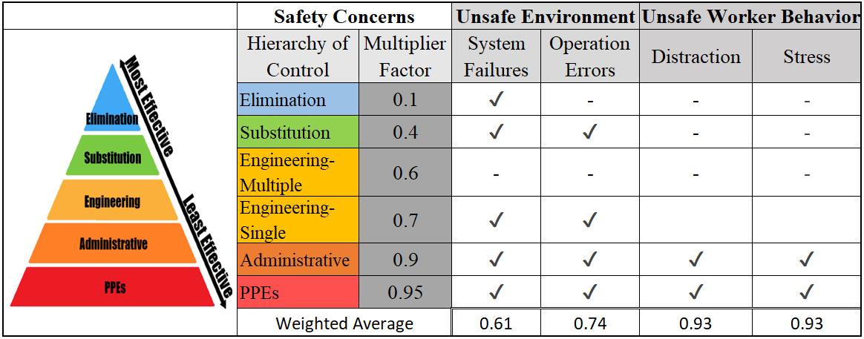

From the weighted average, considering all available control methods, hazards system failures, operation errors, worker distraction, and worker stress received values of 0.61, 0.74, 0.93, and 0.93, respectively. These numbers represent the remaining risk associated with a given hazard in terms of percentage. For example, a weighted average of 0.61 indicates that the remaining risk of the system failures is 61% of the original risk after implementing the identified control methods. In other words, 39% of the mechanical system failures risk associated with the use of UAVs can be eliminated by implementing the recommendations identified in this study.

Based on the findings, it can be observed that the control methods to mitigate system failures are the most effective. It was found that 39% of risks associated with mechanical system failures can be eliminated. Similarly, 24% of risks associated with operation errors can be prevented by implementing the suggested safety controls. On the contrary, the control methods for mitigating the risks of distraction or stress are not very effective (weighted average = 0.93). This means that only 7% of the identified risks can be prevented by implementing the suggested controls. These suggested controls to minimize worker distraction and stress are not highly effective because they neither eliminate the physical hazards nor isolate workers from the hazards. Instead, they are practices to improve worker awareness of the hazards.

Even though the identified control methods could mitigate the risks associated with the use of UAVs in construction, their effectiveness is still relatively low. One suggestion to improve the effectiveness of the identified methods would be to design higher levels of control.

**CONCLUSION AND RECOMMENDATIONS**

This exploratory study presented a preliminary study on the potential negative impacts of using UAVs on construction safety, and identified the potential safety hazards associated with the use of UAVs in construction and recommended solutions to mitigate the identified safety risks. Four main safety risks were identified, namely, system failures, mechanical operation errors, worker distraction, and worker stress. The identified safety risks could cause worker injuries or fatalities by creating unsafe work environment or leading to unsafe worker behavior. With the help of the method proposed by Lyon and Holcroft (2016), this study was able to quantify the remaining risk associated with each hazard after considering the availability of current control methods. The findings of this study revealed that 39% and 26% of risks associated with system failures and operation errors can be eliminated by implementing the suggested controls. That being said, other risks (worker distraction and stress) cannot be effectively mitigated by implementing the suggested controls. According to the study, only 7% of the identified risks associated with worker distraction and stress can be prevented.

The identified safety hazards and recommended solutions provided in this study are important contributions on the topic of UAVs use in construction. It is expected that industry professionals and practitioners could use the presented knowledge to identify the safety risks construction workers are exposed to and implement proper control methods to mitigate the hazards and prevent incidents from occurring. However, due to the limitation of the unstructured review research method used in this study, identified potential safety hazards and corresponding solutions associated with the use of UAVs in construction are not comprehensive. Future research should focus on utilizing a more structured process supported and validated by feedback from industry experts. A structured process supported by feedback from a panel of experts would improve the reliability of the conclusions drawn from this study.

# REFERENCES

BLS. (2017). *Employment by major industry sector.* October 24. <https://www.bls.gov/emp/tables/employment-by-major-industry-sector.htm> (July 20, 2019)

Canis, B. (2015). "Unmanned Aircraft Systems (UAS): Commercial Outlook for a New Industry."

Clarke, R. (2016). "Appropriate Regulatory Responses to the Drone Epidemic." *Computer Law & Security Review* 152-155.

DJI. (2019). *DJI.* <https://www.dji.com/mavic-2-enterprise/specs> (July 10, 2019).

DroneDeploy. (2018). *The Rise of Drones in Construction.* June 6. <https://www.dronedeploy.com/blog/rise-drones-construction-XNpCThIAACcA9X7G/> (July 22, 2019).

FAA. (2018). *Fact Sheet – Small Unmanned Aircraft Regulations (Part 107)*. <https://www.faa.gov/news/fact_sheets/news_story.cfm?newsId=22615> (July 23, 2019).

FAA. (2019). *UAS Sightings Report.* <https://www.faa.gov/uas/resources/public_records/uas_sightings_report/> (July 25, 2019).

Finn, R. L., and Wright, D. (2012). "Unmanned aircraft systems: Surveillance, ethics and privacy in civil applications." *Computer Law & Security Review* 184-194.

Gent, I. P., Jefferson, C., Miguel, I., Moore, N.C.A., Nightingale, P., Prosser, P, Unsworth, C. (2011). "A preliminary review of literature on parallel constraint solving." *PMCS 2011 Workshop on Parallel Methods for Constraint Solving.* 499-504.

Guo, H., Yu, Y., Skitmore, M. (2017). "Visualization technology-based construction safety management: A review." *Automation in Construction* 135-144.

Heinrich, H. W. (1959). "Industrial Accident Prevention. A Scientific Approach." In *Industrial accident prevention; a scientific approach*. McGraw-Hill, 1959.

Hinze, J. W. (1996). "The distractions theory of accident causation." *CIB; Working Commission W99 - Safety and Health on Construction Sites.* Rotterdam, Netherlands: A A Balkema. 375-384.

Hitlin, P. (2017). *8% of Americans say they own a drone, while more than half have seen one in operation.* Dec 19. <https://www.pewresearch.org/fact-tank/2017/12/19/8-of-americans-say-they-own-a-drone-while-more-than-half-have-seen-one-in-operation/> (July 25, 2019).

Howard, J., Murashov, V., Branche, C.M.. (2017). "Unmanned aerial vehicles in construction and worker safety." *American Journal of Industrial Medicine* 61 (1): 3-10.

Irizarry, J., and Costa, D.B. (2016). "Exploratory Study of Potential Applications of Unmanned Aerial Systems for Construction Management Tasks." *Journal of Management in Engineering* 05016001.

Karakhan, A., Xu, Y., Nnaji, C., Alsaffar O. (2019). "Technology Alternatives for Workplace Safety Risk Mitigation in Construction: Exploratory Study." *Advances in Informatics and Computing in Civil and Construction Engineering* 823-829.

Lyon, B. K., and Hollcroft, B.. (2016). "Defining Risk Assessment Criteria." In *Risk Assessment-A practical guide to assessing operational risks*, by Georgi Popov, Bruce K. Lyon and Bruce Hollcroft. Wiley.

McCarley, J. S., and Wickens, C.D. (2004). "Human factors concerns in UAV flight." 1-5.

Melo, R. R. S. d., Costa, D.B., Álvares, J.S., and Irizarry, J. (2017). "Applicability of unmanned aerial system (UAS) for safety inspection on construction sites." *Safety Science* 174-185.

Moud, H. I., Flood, I., Shojaei, A., Zhang, Y., Zhang, X, Tadayon, M., Hatami, M.. (2019). "Qualitative Assessment of Indirect Risks Associated with Unmanned Aerial Vehicle Flights over Construction Job Sites." *Computing in Civil Engineering.* 83-89.

Namian, M., Albert, A, Feng, J. (2018). "The Distracted Worker: Effect on Hazard Recognition and Safety Performance." *Construction Research Congress.* New Orleans; LA: ASCE.

NIOSH. (2015). *Hierarchy of Controls.* January 13. <https://www.cdc.gov/niosh/topics/hierarchy/default.html> (July 20, 2019).

Nnaji, C., & Gambatese, J. A. (2016). "Worker distraction impacts on safety and work quality: An energy component." In Construction Research Congress (CRC) 3005-3014.

Opfer, N. D., and Shields, D.R. (2014). "Unmanned Aerial Vehicle Applications and Issues for Construction." *121st ASEE Annual Conference & Exposition.* Indianapolis, IN. 1-16.

OSHA. (2019). *Commonly Used Statistics.* July 20. <https://www.osha.gov/oshstats/commonstats.html> (July 20, 2019).

Plioutsias, A, Karanikas, N., Chatzimihailidou, M.M. (2017). "Hazard Analysis and Safety Requirements for Small Drone Operations: To What Extent Do Popular Drones Embed Safety?" *Risk Analysis* 562-584.

Haslam, R.A., Hide, S.A., Gibb, A.G.F., Gyi, D.E., Pavitt, T., Atkinson, S., Duff. A.R. (2005). "Contributing factors in construction accidents." *Applied Ergonomics* 401-415.

Siebert, S., and Teizer, J. (2014). "Mobile 3D mapping for surveying earthwork projects using an Unmanned Aerial Vehicle (UAV) system." *Automation in Construction* 1-14.

Xu, Y., and Turkan, Y. (2019). "Bridge Inspection Using Bridge Information Modeling (BrIM) and Unmanned Aerial System (UAS)." *Advances in Informatics and Computing in Civil and Construction Engineering.* Chicago: Springer. 617-624.